***Sohaib Sarosh Shamsi***

***21K-3278 Section E***

***DMA Questions***

Q1. Write a program that asks the user to enter the total 'N' no of  
characters in the user's name {First Name + Last Name} to create a dynamic array of  
characters. After creating a dynamic array of that 'N' no of characters using  
malloc or calloc function. Finally copy your full name in it that has already  
been taken from the user before  
Dynamic Array = "Muhib  
Ahmed"

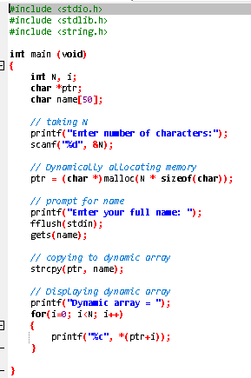

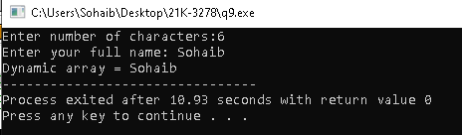

Q2. Using Qus. 9, resize that dynamic array of characters and append the  
array with your studentId. That student id must be taken input from the user.  
DynamicArray= "Muhib Ahmed";                    // Before  
DynamicArray = "K211234Muhib Ahmed";  // After the text append



